**A MEDICAL CHATBOT**

***This mega project is submitted to***

Rashtrasant Tukadoji Maharaj Nagpur University

*in partial fulfilment of the requirements for the award of the degree*

*of*

**Bachelor of Engineering in Information Technology**

**by**

|  |  |
| --- | --- |
| **Ms. Pakhi Pardhi** | **(IT17021)** |
| **Ms. Sanjivani Burchunde** | **(IT17015)** |
| **Mr. Pravin Rahangdale**  **Mr. Abhishek Singh** | **(IT16003)**  **(IT16021)** |
|  |  |
|  |  |

*Under the Guidance of*

**Dr. Dinesh Patil**

**(Assistant Professor)**



**2020-2021**

**DEPARTMENT OF INFORMATION TECHNOLOGY**

**KAVIKULGURU INSTITUTE OF TECHNOLOGY & SCIENCE**

**RAMTEK – 441 106**

**DEPARTMENT OF INFORMATION TECHNOLOGY**

**KAVIKULGURU INSTITUTE OF TECHNOLOGY & SCIENCE**

**RAMTEK – 441 106**



**CERTIFICATE**

**This is to certify that the mega project report entitled ‘A Medical Chatbot’** carried out by Ms. Pakhi Pardhi (IT17021), Ms. Sanjivani Burchunde (IT17015), Mr. Pravin Rahangdale (IT16003), Mr. Abhishek Singh **(IT16021)** of the B.E. final year of Information Technology, during the academic year 2020-2021, in the partial fulfilment of the requirement for the award of the degree of **Bachelor of Engineering (Information Technology) offered by Rashtrasant Tukadoji Maharaj Nagpur University**, Nagpur.

Dr. Dinesh Patil

**Guide**

**Mrs. Saroj Shambharkar Dr. B. Ram Rathan Lal**

**Head of the Department Principal**

**Date: 23/05/2021**

**Place: Ramtek**

**CONTENTS**

*Declaration i*

*Acknowledgement ii*

*Abstract iii*

*Abbreviations vi*

*List of Figures v*

**CHAPTER 1 INTRODUCTION**  1-6

1.1 About Medical Chatbot 1

1.2 Objectives of the study 2

1.3 Existing System 2

1.4 Proposed System 2-3

1.5 Features of Chatbot 3

1.6 Problem Statement 4

1.7 Purpose 4

1.8 Scope 4

1.9 Applications 4

1.10 Advantages 4-5

1.11 Disadvantages 5-6

1.12 Motivation 6

1.10 Users 6

**CHAPTER 2 PROPOSED APPROACH AND** 7-9

**SYSTEM ARCHITECTURE**

2.1 Proposed Approach 7

3.2 Modules 7-8

3.3 Software and Hardware Requirements 8

3.4 System Architecture 8-9

**CHAPTER 3 LITERATURE SURVEY** 10-13

**CHAPTER 4 SYSTEM DESCRIPTION** 14-23

4.1 Design 14-18

4.1.1 System Architecture 14

4.1.2 Software Architecture 16

4.1.3 Use Case Diagram 16

4.1.4 Class Diagram 16-17

4.1.5 Sequence Diagram 17-18

4.2 Methodology Used 19

4.3 Goals 19

4.4 Dataset Details 19-20

4.5 Project Implementation 20

4.6 Experimental Setup 20-25

4.7 Result(snapshot) 26-29

**CHAPTER 5 CONCLUSION AND FUTURE SCOPE**  30

5.1 Conclusion 30

5.2 Future Scope 30

5.3 References 30

**DECLARATION**

We declare that

1. The work contained in this mega-project has been done by us under the supervision of our guide.
2. The work has not been submitted to any other Institute for any degree or diploma.
3. We have followed the guidelines provided by the Institute in preparing the project report.
4. We have conformed to the norms and guidelines given in the Ethical Code of Conduct of the Institute.
5. Whenever we have used material (data, theoretical analysis, figures and text) from other sources. We have given due credit to them in the text of the report and giving their details in the references. Further, we have taken permission from the copyright owners of the sources, whenever necessary.

**ACKNOWLEDGMENT**

**We are grateful to our respected guide Dr. Dinesh Patil for his kind, disciplined and invaluable guidance which inspired us to solve all the difficulties that came across during completion of project.**

**We express our special thanks to Mrs. Saroj Shambharkar, Head of the Department, for her kind support, valuable suggestion and allowing us to use all facilities that are available in the Department during this project.**

**Our sincere thanks to Dr. B. Ram Rathan Lal, Principal, for extending all the possible help and allowing us to use all resources that are available in the Institute.**

**We are also thankful to our Parents and Friends for their valuable cooperation and standing with us in all difficult conditions.**

**Project-mates**

**ABSTRACT**

The main aim of project **“A MEDICAL CHATBOT”** is to help you better visualize the presentation of mined data (information). It deals with all the health care issues which will really benefit stakeholders in the health care space. To start a good life healthcare is very important. But it is difficult to obtain the consultation with the doctor in case of any health issues. The proposed idea to present a design for a medical Chatbot that provides diagnosis and remedies based on the symptoms provided to the system. The system will be able to measure the seriousness of the diagnosis and if needed, it will connect the user to a doctor available online. This Chat-bot also gives information about the hospitals situated near-by to the user and other necessities. The system provides text (or) voice assistance you can communicate with the bot like user friendly.

Chatbots are automated systems which replicate user’s behaviour on one side of the chatting communication. They are mimic systems which imitate the conversations between two individuals. They provide a simulating platform for effective and smart communications with the user on the other end. They copy marketers, sales person, counsellors and other mediators and work to provide services that the abovementioned people provide. There are wide ranges of chatbots catering in many domains some of them are as follows: business, market, stock, customer care, healthcare, counselling, recommendation systems, support system, entertainment, brokering, journalism, online food and accessory shopping, travel chatbots, banking chatbots, recipe guides, etc. The most famous chatbots like Alexa or Google assistant are the best examples that can be given for smart communicating chatbots. These are general purpose chatbots that provide services for all domains and are not restricted to a specific domain. There are also domain-specific chatbots which provide functionalities to the above-mentioned domains. Some of them are as follows: Botsify is a chatbot which helps developers to create smart Facebook Messenger Chatbots and is used to collect information from Facebook users. Imperson is a chatbot which helps developers to create business chatbots and provide customer care services.

**Keywords:** Doctors, Symptoms, Patient

**ABBREVIATIONS**

**Abbreviations Meaning**

NLP Natural Language Processing

CSV Comma-separated values

**LIST OF FIGURES**

|  |  |
| --- | --- |
| SR NO. | FIGURES NAME |
| 1 | System Architecture |
| 2 | Software Architecture |
| 3 | Use Case Diagram |
| 4 | Class Diagram |
| 5 | Sequence Diagram |

**CHAPTER 1**

**Introduction**

* 1. **ABOUT MEDICAL CHATBOT**

A chatbot is a software application used to conduct an on-line chat conversation via text or text-to-speech, in order to provide direct contact with a live human agent. The proposed Medical Chatbot can interact with the users, giving them a realistic experience of chatting with a Medical Professional. It retrieves keywords from the initial messages to know the possible medical problems that the user has, based on their input. There are few Medical Chatbots that already exist, but they do not provide users with medication to any illness but connect them with a Medical QA Forum and show them similar questions to their symptoms that doctors may have previously answered.

Through chat bots one can communicate with text or voice interface and get reply through artificial intelligence. Typically, a chat bot will communicate with a real person. Chat bots are used in applications such as ecommerce customer service, call centres and Internet gaming. Chat bots are programs built to automatically engage with received messages. Chat bots can be programmed to respond the same way each time, to respond differently to messages containing certain keywords and even to use machine learning to adapt their responses to fit the situation. A developing number of hospitals, nursing homes, and even private centres, presently utilize online Chat bots for human services on their sites. These bots connect with potential patients visiting the site, helping them discover specialists, booking their appointments, and getting them access to the correct treatment.

Medical chatbots are AI-powered conversational solutions that help patients, insurance companies, and healthcare providers easily connect with each other. These bots can also play a critical role in making relevant healthcare information accessible to the right stakeholders, at the right time.

**1.2 Objectives of the Study**

A medical chatbot facilitates the job of a healthcare provider and helps improve their performance by interacting with users in a human-like way. There are countless cases where intelligent medical chatbots could help physicians, nurses, therapists, patients, or their families.

Chatbots are software developed with machine learning algorithms, including natural language processing (NLP), to stimulate and engage in a conversation with a user to provide real-time assistance to patients.

Chatbot will perform following tasks:

* providing health-related information to users
* guidance for patient
* doctor’s link
* connecting people and organizations with first responders
* FAQ-type queries (contact details, directions, opening hours and service/treatment details)

**1.3 EXISTING SYSTEM**

Doctors are very important and they do their best to be available all the time and dedicate enough attention to each patient. But the problem is, doctors are usually on a tight schedule and being available for every patient is impossible at times. Hence patient have to wait for a long time. User can do normal conversation with the chatbot.

**1.4 PROPOSED SYSTEM**

Many of the existing systems have some limitation such as there is no instant response given to the patients they have to wait for experts acknowledgement for a long time. Some of the processes may charge amount to perform live chat or telephony communication with doctors online.

To overcome the problems faced by existing system, we build up a system “chatbot” which is useful for people or hospitals to help the users to freely ask medical doubts and concerns over text. System will get output for the disease. User can get related answer displayed on software and refer it for analysis.

**1.5 Features of Chatbot**

Chatbots provide a single answer to most questions, they are able to present concise information from credible sources, which may be less overwhelming than social media or web search engines long list of results. These matters because false news spreads online both faster and further than accurate news. Chatbots, in contrast to newspapers and online information sources, can often hear and respond in natural language, improving access for people who cannot read or have difficulty using the internet. They can be available any time of the day to answer questions with up-to-date information, and unlike human experts, can concurrently speak with millions of people at the same time in local languages and dialects.

* 1. **PROBLEM STATEMENT**

This project aims to present a design for a medical Chatbot that provides diagnosis and remedies based on the symptoms provided to the system. The system will be able to measure the seriousness of the diagnosis and if needed, it will connect the user to a doctor available online. This Chat-bot also gives information about the hospitals situated near-by to the user and other necessities.

PROBLEM OBJECTIVES

1. Chat bot should give an appropriate answer to the user.
2. To manage the details about the questions and answers asked by the user.
3. To train our chatbot for its effective running.
4. To deal with monitoring the information about the questions asked by the users.
5. Updating, adding, editing of records which provide information about the hospitals, and other necessities.
6. To manage options like location and their health issues.

**1.7 Purpose**

A chatbot is a computer program that simulates human conversation through voice commands or text chats or both. Chatbot, short for chatterbot, is an Artificial Intelligence (AI) feature that can be embedded and used through any major messaging applications.

**1.8 Scope**

Machine learning has changed the way companies were communicating with their customers. With new platforms to build various types of chat bots being introduced, it is of great excitement to witness the growth of a new domain in technology while surpassing the previous threshold.

**1.9 Applications**

* Medical chatbots are AI-powered conversational solutions that help patients, insurance companies, and healthcare providers easily connect with each other.
* A medical chatbot facilitates the job of a healthcare provider and helps improve their performance by interacting with users in a human-like way. There are countless cases where intelligent medical chatbots could help physicians, nurses, therapists, patients, or their families.
* Chatbots are used on a daily basis by the user.
* It reduces the time of patient as early diagnosis is possible.
* It will provide link of the doctor so that patient can visit him/her on their link.

**1.10 Advantages**

1. Accessible anytime:

On an average people spend around 7 minutes until they are assigned to a person. Gone are the frustrating days of waiting in a queue for the next available operative. They are replacing live chat and other forms of slower contact methods such as emails and phone calls. Since chat bots are basically virtual robots, they never get tired and continue to obey your command. They will continue to operate every day throughout the year without requiring to take a break

2. Handling Capacity:

Unlike humans who can only communicate with one human at a time, chat bots can simultaneously have conversations with thousands of people. No matter what time of the day it is or how many people are contacting you, every single one of them will be answered immediately.

3. Omni-capable

The chat bot converses seamlessly across multiple digital channels and retains data and context for a seamless experience. In best cases, even passing that information to a live agent if needed.

4. Free to Explore

The chat bot can reach, consume, and process vast amounts of data– both structured and unstructured–to surface insights from any source - to gather relevant data to solve customer issues quickly.

5. Pre-Trained

The chat bot is pre-trained to understand brand-specific or industry-specific knowledge and terms. Even better, it’s pre-configured to resolve common customer requests of a particular industry.

6. User Interface

A user-friendly interface which is engaging and easy to access.

**1.11 Disadvantages**

1.Complex Interface

Chatbots are often seen to be complicated and require a lot of time to understand user’s requirement. It is also the poor processing which is not able to filter results in time that can annoy people.

2. Inability to Understand

Due to fixed programs, chatbots can be stuck if an unsaved query is presented in front of them. This can lead to customer dissatisfaction and result in loss. It is also the multiple messaging that can be taxing for users and deteriorate the overall experience on the website.

3. Time-Consuming

Chatbots are installed with the motive to speed-up the response and improve customer interaction. However, due to limited data-availability and time required for self-updating, this process appears more time-taking and expensive. Therefore, in place of attending several customers at a time, chatbots appear confused about how to communicate with people.

**1.12 Motivation**

The development of this project was motivated to help the patient to get advice related to their health. User can ask health related issues to the chatbot. It gives the appropriate answers to the users.

**1.13 User**

* Admin can update the dataset.
* Patients can put their queries before chatbot.
* Doctors can also contact their respective patients.

**CHAPTER 2**

**Proposed Approach and System Architecture**

**2.1 Proposed approach**

System will provide chatbot for effective talking with the user. Users can access different options according to their problems. Users will ask the health-related questions to get access of Chatbot. Admin who can have information controls chatbot in background.

The options that can be provided to Users are as follows:

A. User Login to System: User registers on Chatbot application. Then ask queries regarding to the health care and medical details.

B. Ask some Questions: You can ask some questions regarding some healthcare. And its related to voice- text and text-voice conversation. Using Google API for inter conversion of text-voice and vice versa.

D. Get Medicine Details on medicine name: You can ask about medicine related details on the basis of medicine names.

E. Disease Prediction Depending on the disease symptoms: AI algorithm can predict the disease.

**2.2 Plan of Implementation**

**Modules:**

**A. Ask the questions to Chatbot (Module-1):** Users can ask the health-related problems to the chatbot. Chatbots are intended to provide health and therapy information to users, provide services to patients, as well as suggest diagnoses and recommend treatments based on user symptoms. It will also provide nearby hospital address link to them.

**B. Communication of Chatbot and its Database (Module-2):** Upon receiving personal queries like problems of the users, symptoms, etc. the input text is processed to extract keywords. Based on the keywords, information required by the user is understood and the information is stored in the database. Other data provided to the chatbot such as username, gender, etc. are also saved. This is done by Chatterbot and Chatterbot library in the python.

**C. NLP Response System (Module-3):** If the user is trying to make a conversation with the bot, the input is matched with the data present in database using NLP Algorithm. If the response is available, it is sent to the chatbot.

**D. Answering to the user (Module-4):** When a user wants some information pertaining to their health, the response will be provided through this module. If the input matches a with the dataset in the NLP, the appropriate response will be sent to the user. An algorithm to check sentence similarity (NLP) is applied to the modified input to check its similarity with the questions of a predefined question-set, whose answers are available. Also, a random response is sent to the user suggesting “Answer not available” if the input is not matched with the data set.

**2.3 Tools/Technologies used**

* Software Requirement

● Operating system - Windows 10 (64 bit, 8th generation, i5 processor)

● Language - Python

● Software Development Kit- PyCharm

Hardware Requirements

● Processor - Intel Core @1.60GHz

● RAM - 8.00 GB

**2.4 System Architecture**

**RESEARCH PROCESS**

Research exercise may take many forms but systematic enquiry is features common to all such forms. Being a systematic enquiry, it requires careful planning of the orderly investigation process. We enquired about canteen to the workers employed in the canteen. We discuss about how many students, staffs visited canteen daily on an average. We discuss about the food items brought by users on a daily basis. We also focus on the problems faced by the users and the canteen owner.

In planning and designing a specific research project, it is necessary to anticipate all the steps that must be undertaken if the project is to be successful in collecting valid and reliable information. After discussing with the canteen workers, we mainly focus on order and delivery of food. We made the solution for it in the forms of use case diagrams, data flow diagrams.

**cHAPTER 3**

**Literature REVIEW**

**1] Adam S. Miner, Liliana Laranjo and A. Baki Kocaballi [MAY 2020]** launch a chatbot to help patients with questions about Covid-19, leaders recognized that the kind of information patients were seeking (based on call centre interactions) often requires an institution-specific response. Even standardized responses to symptom checker questions need to be crafted in a manner consistent with the local capabilities and pathways of the health system in which the initiative is based. The need for unique response mapping, complex contextualization, and dynamic, human-guided validation of content led leaders to develop a specialized chatbot through collaboration with companies experienced in machine learning and natural language processing. Two weeks after the initial planning meeting with the companies, the chatbot went live.

Throughout the U.S., people are struggling with questions, lots of questions, about Covid-19. Seeking answers, they turn to whatever resources are available: the Internet, friends and family, or they try to reach their clinicians for guidance. Medical call centers and clinicians bear the brunt of this volume burden as patients seek reliable answers to questions about Covid-19, the risks for them and their families, and the disruptions it introduces to their usual health maintenance.

Many of the questions patients have about Covid-19 are questions that other patients have as well, like What are symptoms of Covid-19? or What should I do if I fear I have been exposed? or Where can I get tested? While each patient has a unique medical history, many of these questions lend themselves to standardized answers that should reflect the most up-to-date knowledge and guidelines about the virus and be readily accessible for patients.

Across a wide range of industries, chatbots have been an efficiency-enhancing way for business teams to interact with their customers. Chatbots are conversational agents that leverage machine learning and natural language processing to understand intent in order to reply with appropriate answers, and they have advantages relevant to the present crisis.[1](https://catalyst.nejm.org/doi/full/10.1056/cat.20.0230#r1)-[3](https://catalyst.nejm.org/doi/full/10.1056/cat.20.0230#r3) First, they are accessible any time, allowing patients to obtain answers 24/7 and to avoid wait times on hold before reaching a human. Second, chatbots have a higher handling capacity than any human.[4](https://catalyst.nejm.org/doi/full/10.1056/cat.20.0230#r4) A single chat bot can simultaneously have conversations with thousands of people no matter what time of day. Regardless of the volume of calls, every question may be answered immediately.

**2] Mrs. Rashmi Dharwadkar , Dr.Mrs. Neeta A. Deshpande[2018]**

This system helps users to submit their complaints and queries regarding the health. Customer satisfactions the major concern for developing this system. . The actual welfare of the chatbot is the facilitate the people by giving proper guidance regarding the good and healthy living. For the reason that many of the people do not have fundamental awareness of physical condition. Some people live for years with debilitating but they do not pay attention to symptoms simply because they think they don’t require a doctor.

Some chatbots are compact medical reference books which are useful not only for patients, doctors etc but also for those who want to learn something about health. The user feels that they are incorporated in the process of their health. Patients who feel included, who are interacting through chatbots with the healthcare system, will stay with the system, and that is important for them and the healthcare provider. The old chatbot are client communications systems and their best effort is a question and answer page on a website. Bot can facilitate to get the common health related question and prediction of disease without a human interference.

This system giving the accurate result. As we are using large dataset which will ensures the better performance compared as earlier. Thus we build up a system which is useful for medical institute or hospitals to help the users to freely ask medical dosage related queries by voice. System gets output for medicine API and speak out and display all medicine names. They are using NLP because we want to a computer to communicate with users in their terms. So by using SVM algorithm and disease symptoms system can predict disease. User can get related answer displayed r on android app

**3] Krishnendu Rarhi, Abhishek Bhattacharya, Abhishek Mishra, Krishnasis Mandal[April 24, 2018]**

The system focuses on the messages that the user provides while initiating the conversation. The idea behind this is to detect the preliminary symptoms and the problems that the user may be experiencing. After the Chatbot has collected enough keywords from the initial messages, it now starts leading the conversation by asking questions to the user and trying to shortlist few diseases that the user may be suffering through. After the Chatbot has shortlisted the possible diseases that the user may have, now it gives a rank to the possible diseases that the user may be suffering from. When the list of possible diseases, the Chatbot starts questioning the user about how the user is feeling. Once it gets ample amount of data it finds the most likely disease that the user may be suffering through. After the Chatbot has found the disease that the user is suffering through, it measures the seriousness of the illness and acts accordingly either by suggesting remedies and medication to the user or by connecting the user to the doctor if the measure hits the predetermined threshold value.

Medical Chatbot will have a great impact on the life of its users. It would provide them the advantage of carrying a virtual Doctor in their pockets. It would also give them the freedom to consult a doctor 24/7 and also can get a real doctor's advice if needed. This can be a most popular tool for people with busy schedule as they won't have to hamper their schedule to consult a doctor for minor health queries. This would also be a tool with high utility among elderly and physically disabled people as this can help them get solutions to all their health related issue at their fingertips. We would bring Doctors and Medical Professionals to our platform to feed the medical data into our records and also to chat with our users when required. Having lots of medical data would make our Chatbot function more efficiently and accurately. Our Chatbot is in a design phase right now. We would be implementing the whole design into code very soon and we plan to launch it in the next few months. We are implementing the Chatbot engine in JAVA and using Pandorabot as the AIML platform. We also plan to design and make a device that people could wear and let it collect their important body readings and health data. We would make the device using raspberry pi and would make it compatible with our Chatbot and many others services as well using APIs.

**4]Tobias Kowatsch, Marcia Nißen , Chen-Hsuan Iris Shih , Dominik Rüegger[2018]**

In this work, we described one concrete instance of a text-based healthcare chatbot (THCB) system that was designed to support patients and health professionals likewise. Interim analysis of the intervention group from an ongoing RCT indicate that the implemented THCB, which took over the role of a peer character, engaged patients over four months to a remarkable extent. Moreover, more than 99.5% of the conversational turns were driven by the THCB which underlines their scalability of THCBs. Patients’ perceptions regarding enjoyment and attachment bond with the THCB were also found to be good.

The app allows the integration of visual THCB cues in a dedicated chat channel. This channel also provides pre-defined answer options for efficient chat interactions compared to traditional text-messaging systems. Moreover, we have implemented a second chat channel for patient and health professional communication like WhatsApp or iMessage and situations in which the THCB is unable to support patients in an automated way.

**CHAPTER 4**

**SYSTEM DESCRIPTION**

**4.1 DESIGN**

**4.1.1 System Architecture:**

An architectural diagram is a diagram of a system that is used to abstract the overall outline of the software system and the relationships, constraints, and boundaries between components.

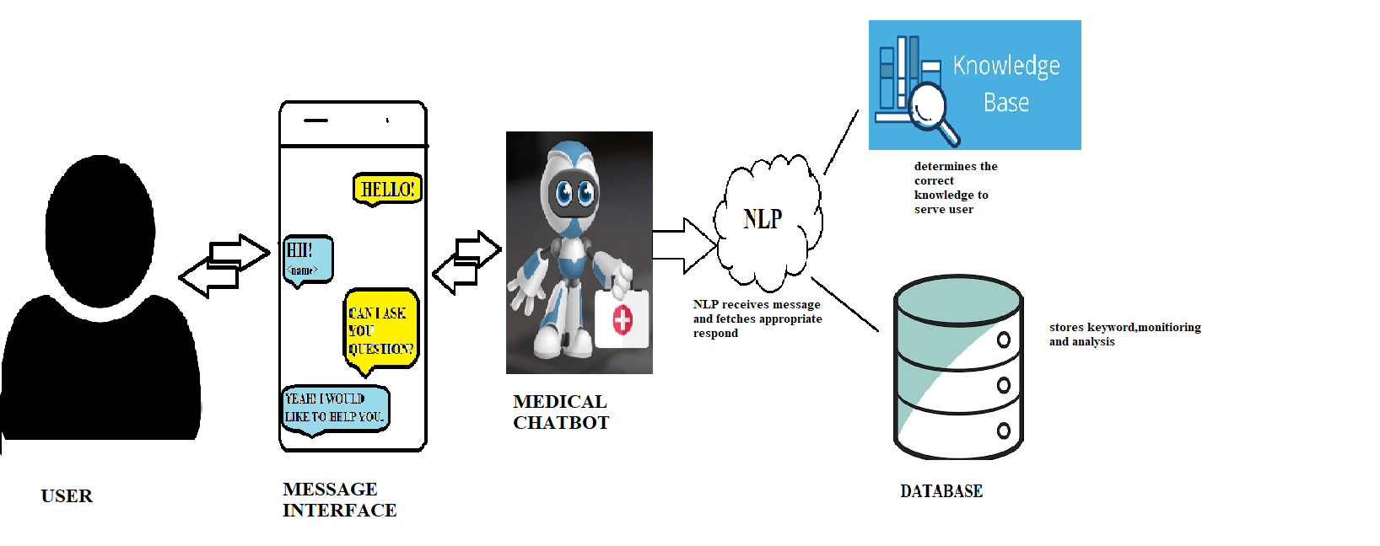

**4.1.2 Software Architecture Diagram:**

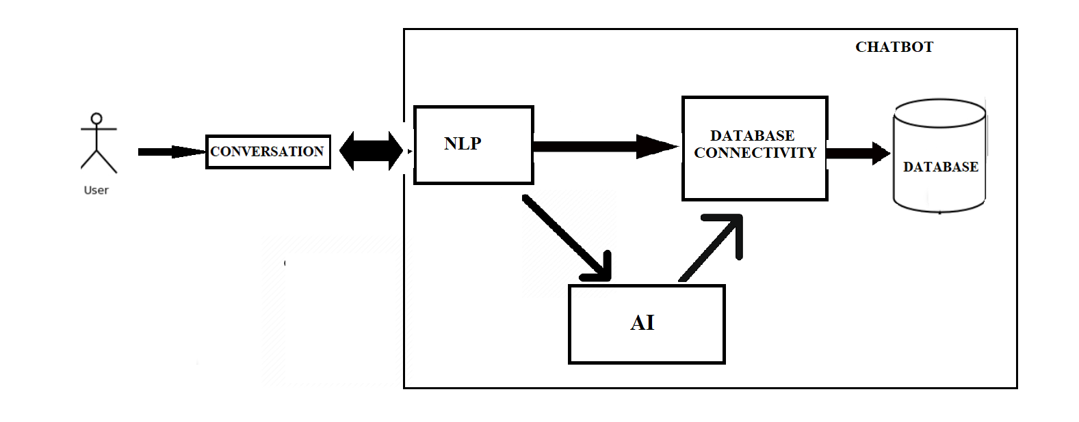

**4.1.3 Use Case Diagram:**

A use case is a description of how end-users will use a software code. It describes a task or a series of tasks that users will accomplish using the software and includes the responses of the software to user actions.

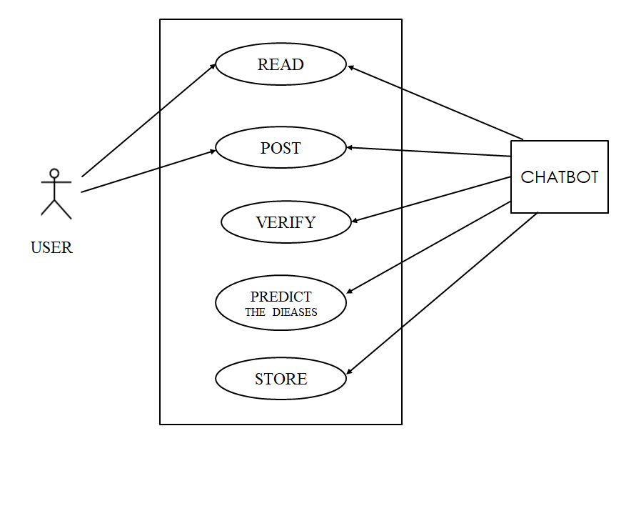

fig. Use Case Diagram for Medical Chatbot

**4.1.4 Class Diagram**

In the Unified Modelling Language (UML), a class diagram is a type of static structure diagram that describes the structure of a system by showing the system's classes, their attributes, and the relationships between the classes.

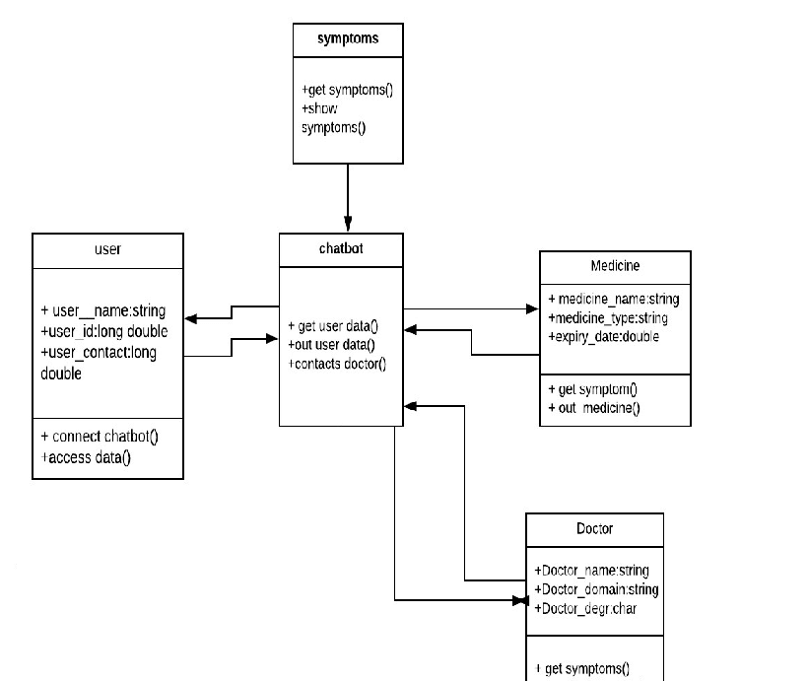

Fig. Class Diagram for Medical Chatbot

**4.1.3 Sequence Diagram:**

A sequence diagram in Unified Modelling Language (UML) is a kind of interaction diagram that shows how processes operate with one another and in what order. It is a construct of a Message Sequence Chart. Sequence diagrams are sometimes called event diagrams, event scenarios, and timing diagrams.

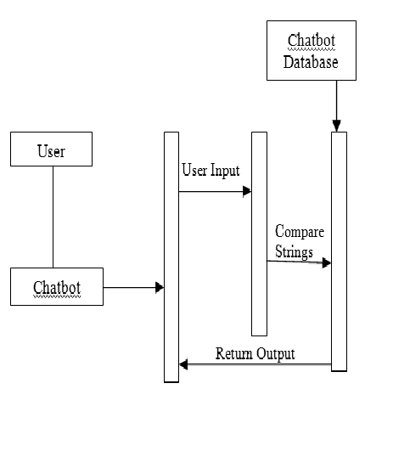

Fig. Sequence Diagram for Medical Chatbot

**4.2 Methodology Used:**

The Health-Care Chat Bot System should be written in Python, GUI links and a simple, accessible network API. The system must provide a capacity for parallel operation and system design should not introduce scalability issues with regard to the number of surface computers, tablets or displays connected at any one time. The end system should also allow for seamless recovery, without data loss, from individual device failure. There must be a strong audit chain with all system actions logged. While interfaces are worth noting that this system is likely to conform to what is available. With that in mind, the most adaptable and portable technologies should be used for the implementation. The system has criticality in so far as it is a live system. If the system is down, then customers must not notice, or notice that the system recovers quickly (seconds). The system must be reliable enough to run, crash and glitch free more or less indefinitely, or facilitate error recovery strong enough such that glitches are never revealed to its end-users.

**4.3 Goals:**

The main purpose of the scheme is to build the language gap between the user and health providers by giving immediate replies to the Questions asked by the user. Today’s people are more likely addicted to the internet but they are not concerned about their personal health. They avoid going to hospital for small problems which may become a major disease in future. Establishing question answer forums is becoming a simple way to answer those queries rather than browsing through the list of potentially relevant documents from the web. Many of the existing systems have some limitations such as there is no instant response given to the patients they have to wait for experts to acknowledge for a long time. Some of the processes may charge an amount to perform live chat or telephony communication with doctors online. The aim of this system is to replicate a person’s discussion.

**4.4 Dataset Details:**

Dataset contains description of different types of diseases. There are different sets of different types of diseases. These sets consist of descriptions of a single disease with different doctors, hospitals, etc. A dataset has been created by recording sequences from over 133 number of diseases and doctors and hospitals. We are using large dataset (81 symptoms, 50 dis eases and 41 doctor’s dataset) which will ensure the better performance.

* 1. **Project Implementation Technology:**

In machine learning, Natural Language Processing (NLP) are supervised learning models with associated learning algorithms that analyze data used for classification and regression analysis. Given a set of training examples, each marked as belonging to one or the other of two categories, an SVM training algorithm builds a model that assigns new examples to one category or the other, making it a non-probabilistic binary linear classifier (although methods such as Platt scaling exist to use NLP in a probabilistic classification setting). An NLP model is a representation of the examples as points in space, mapped so that the examples of the separate categories are divided by a clear gap that is as wide as possible. New examples are then mapped into that same space and predicted to belong to a category based on the side of the gap on which they fall. In addition to performing linear classification, NLP can efficiently perform a non-linear classification using what is called the kernel trick, implicitly mapping their inputs into high dimensional feature spaces.

**4.6 Experimental Setup:**

The main purpose of the scheme is to build the language gap between the user and health providers by giving immediate replies to the Questions asked by the user. Today’s people are more likely addicted to the internet but they are not concerned about their personal health. They avoid going to hospital for small problems which may become a major disease in future. Establishing question answer forums is becoming a simple way to answer those queries rather than browsing through the list of potentially relevant documents from the web. Many of the existing systems have some limitations such as there is no instant response given to the patients, they have to wait for experts to acknowledge for a long time. Some of the processes may charge an amount to perform live chat or telephony communication with doctors online.

**CODE:**

# Importing the libraries  
import numpy as np  
import matplotlib.pyplot as plt  
import pandas as pd  
  
# Importing the dataset  
training_dataset = pd.read_csv('Training.csv')  
test_dataset = pd.read_csv('Testing.csv')  
  
# Slicing and Dicing the dataset to separate features from predictions  
X = training_dataset.iloc[:, 0:132].values  
y = training_dataset.iloc[:, -1].values  
  
# Dimensionality Reduction for removing redundancies  
dimensionality_reduction = training_dataset.groupby(training_dataset['prognosis']).max()  
  
# Encoding String values to integer constants  
from sklearn.preprocessing import LabelEncoder  
  
labelencoder = LabelEncoder()  
y = labelencoder.fit_transform(y)  
  
# Splitting the dataset into training set and test set  
from sklearn.model_selection import train_test_split  
  
X_train, X_test, y_train, y_test = train_test_split(X, y, test_size=0.25, random_state=0)  
  
# Implementing the Decision Tree Classifier  
from sklearn.tree import DecisionTreeClassifier  
classifier = DecisionTreeClassifier()  
classifier.fit(X_train, y_train)  
  
# Saving the information of columns  
cols = training_dataset.columns  
cols = cols[:-1]  
  
# Checking the Important features  
importances = classifier.feature_importances_  
indices = np.argsort(importances)[::-1]  
features = cols  
  
# Implementing the Visual Tree  
from sklearn.tree import _tree  
  
  
# Method to simulate the working of a Chatbot by extracting and formulating questions  
def execute_bot():  
 print("Please reply with yes/Yes or no/No for the following symptoms")  
  
 def print_disease(node):  
 # print(node)  
 node = node[0]  
 # print(len(node))  
 val = node.nonzero()  
 # print(val)  
 disease = labelencoder.inverse_transform(val[0])  
 return disease  
  
 def tree_to_code(tree, feature_names):  
 tree_ = tree.tree_  
 # print(tree_)  
 feature_name = [  
 feature_names[i] if i != _tree.TREE_UNDEFINED else "undefined!"  
 for i in tree_.feature  
 ]  
 # print("def tree({}):".format(", ".join(feature_names)))  
 symptoms_present = []  
  
 def recurse(node, depth):  
 indent = " " * depth  
 if tree_.feature[node] != _tree.TREE_UNDEFINED:  
 name = feature_name[node]  
 threshold = tree_.threshold[node]  
 print(name + " ?")  
 ans = input()  
 ans = ans.lower()  
 if ans == 'yes':  
 val = 1  
 else:  
 val = 0  
 if val <= threshold:  
 recurse(tree_.children_left[node], depth + 1)  
 else:  
 symptoms_present.append(name)  
 recurse(tree_.children_right[node], depth + 1)  
 else:  
 present_disease = print_disease(tree_.value[node])  
 print("You may have " + present_disease)  
 print()  
 red_cols = dimensionality_reduction.columns  
 symptoms_given = red_cols[dimensionality_reduction.loc[present_disease].values[0].nonzero()]  
 print("symptoms present " + str(list(symptoms_present)))  
 print()  
 print("symptoms given " + str(list(symptoms_given)))  
 print()  
 confidence_level = (1.0 * len(symptoms_present)) / len(symptoms_given)  
 print("confidence level is " + str(confidence_level))  
 print()  
 print('The model suggests:')  
 print()  
 row = doctors[doctors['disease'] == present_disease[0]]  
 print('Consult ', str(row['name'].values))  
 print()  
 print('Visit ', str(row['link'].values))  
 # print(present_disease[0])  
  
 recurse(0, 1)  
  
 tree_to_code(classifier, cols)  
  
  
# This section of code to be run after scraping the data  
  
doc_dataset = pd.read_csv('doctors_dataset.csv', names=['Name', 'Description'])  
  
diseases = dimensionality_reduction.index  
diseases = pd.DataFrame(diseases)  
  
doctors = pd.DataFrame()  
doctors['name'] = np.nan  
doctors['link'] = np.nan  
doctors['disease'] = np.nan  
  
doctors['disease'] = diseases['prognosis']  
  
doctors['name'] = doc_dataset['Name']  
doctors['link'] = doc_dataset['Description']  
  
record = doctors[doctors['disease'] == 'AIDS']  
record['name']  
record['link']  
  
# Execute the bot and see it in Action  
execute_bot()

**Testing:**

Without a well-thought testing effort, the project will undoubtedly fail overall and will impact the entire operational performance of the solution. With a poorly tested solution, the support and maintenance cost will escalate exponentially, and the reliability of the solution will be poor. Therefore, project managers need to realize that the testing effort is a necessity, not merely as an ad hoc task that is the last hurdle before deployment. The project manager should pay specific attention to developing a complete testing plan and schedule. At this stage, the project manager should have realized that this effort would have to be accommodated within the project budget, as many of the testing resources will be designing, testing, and validating the solution throughout the entire project life cycle—and this consumes work-hours and resources. The testing effort begins at the initial project phase (i.e. preparing test plans) and continues throughout until the closure phase.

**4.7 Result**

**Snapshot:**

**1.home screen**

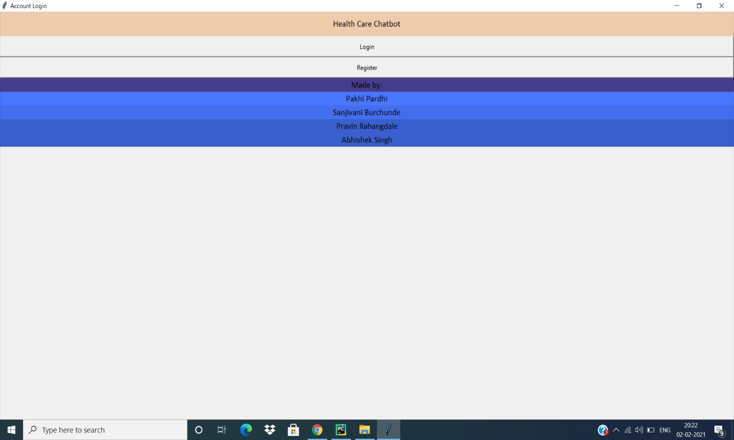

**2.LOGIN SCREEN**

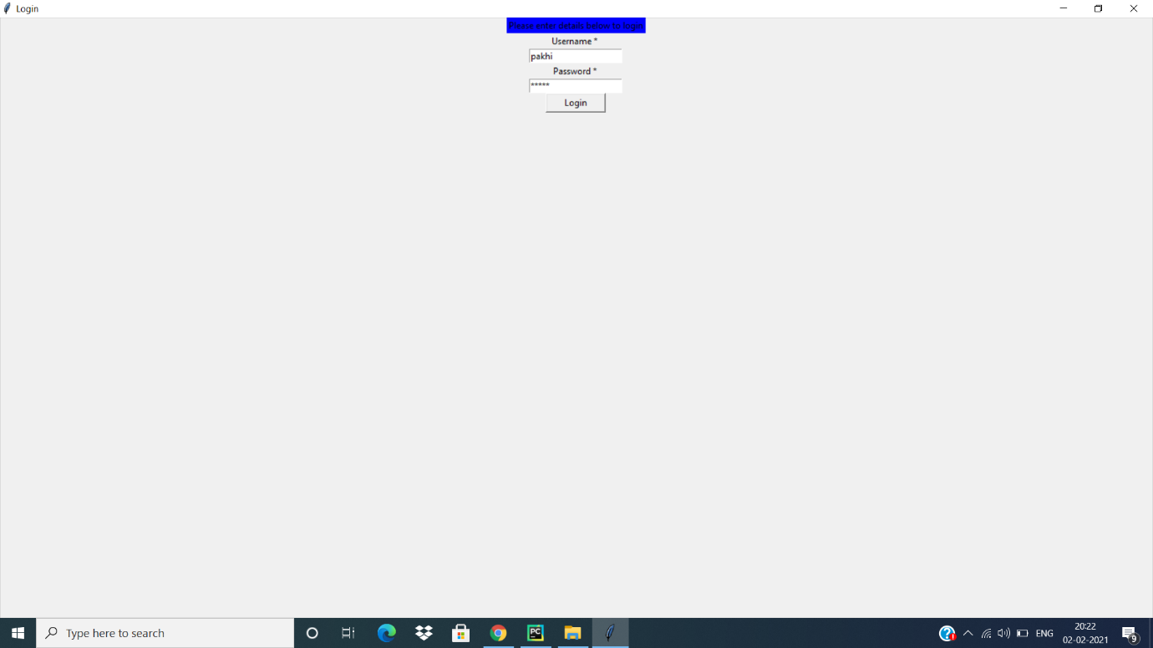

**3. REGISTRATION SCREEN**

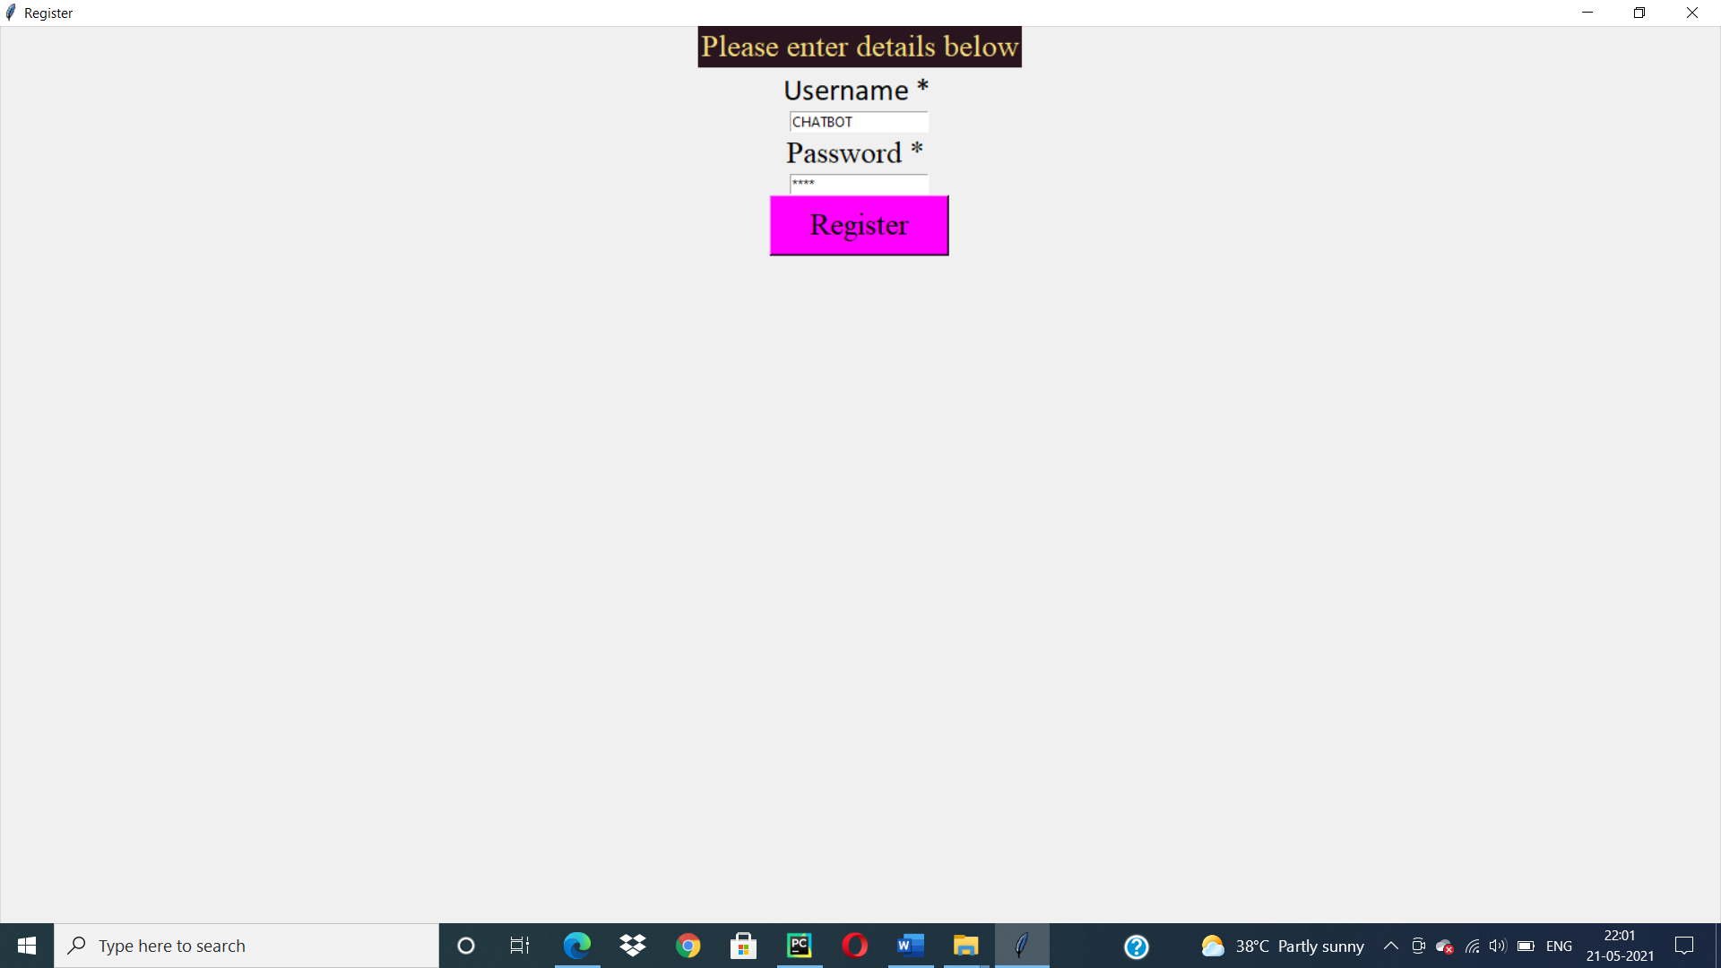

**4. CONFIRMATION SCREEN**

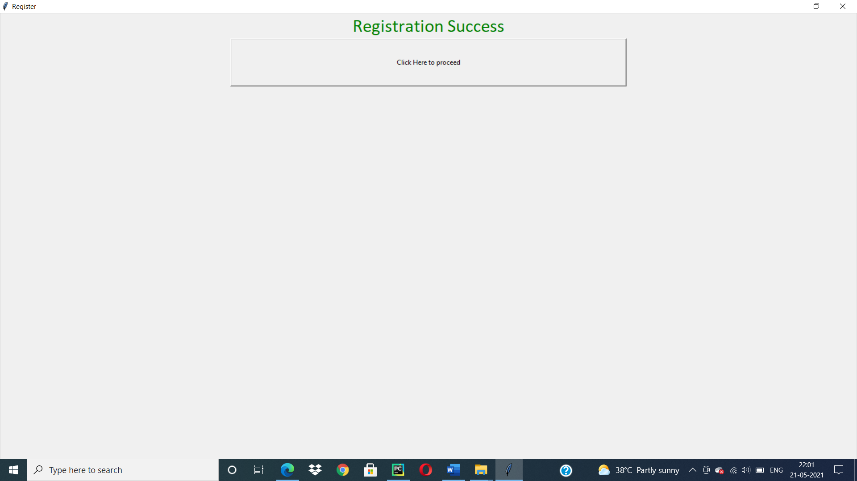

**RESULT**

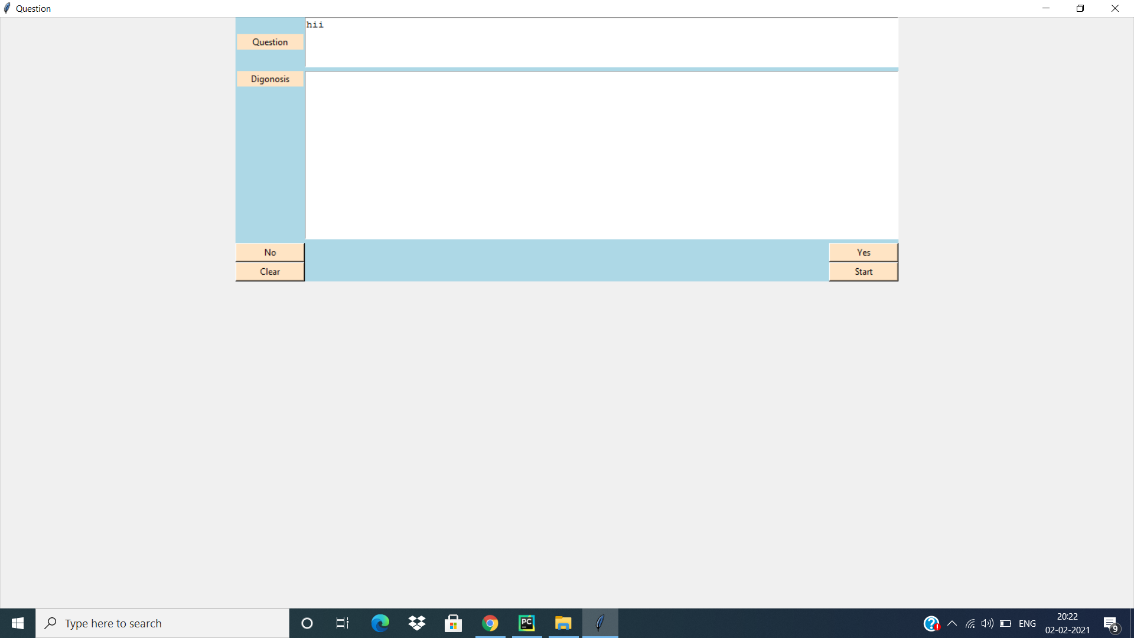

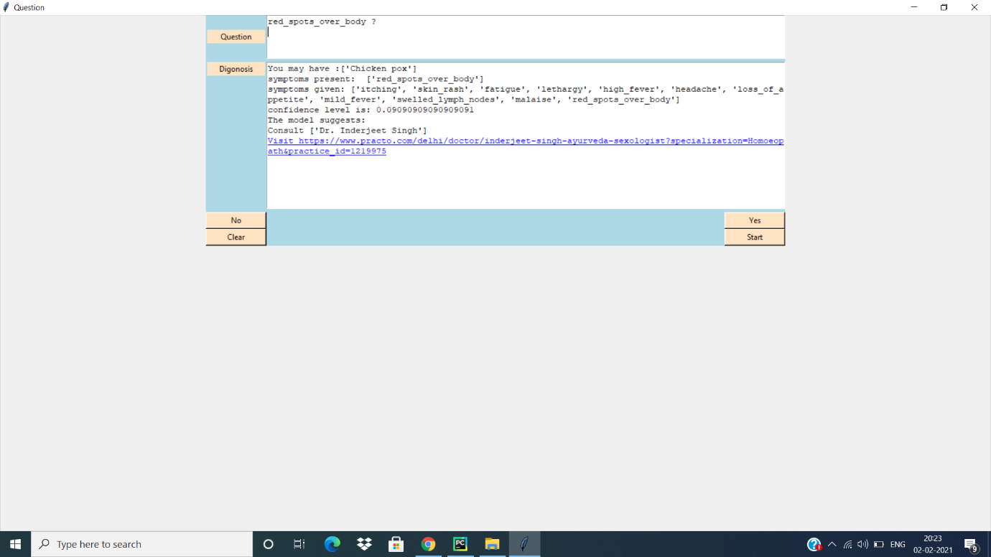

**CHAPTER 5**

**CONCLUSION AND FUTURE SCOPE**

**5.1 CONCLUSION**

Thus, we can conclude that this system giving the accurate result. As we are using large dataset which will ensures the better performance. Thus, we build up a system which is useful for people to detect the disease by typing symptoms.

**5.2 FUTURE SCOPE**

Chat bots are a thing of the future which is yet to uncover its potential but with its rising popularity and craze among companies, they are bound to stay here for long. Machine learning has changed the way companies were communicating with their customers. With new platforms to build various types of chat bots being introduced, it is of great excitement to witness the growth of a new domain in technology while surpassing the previous threshold.

**5.3 REFERENCES**

[1] WHO. WHO Health alert brings diseases facts to billions. WHO https://web.archive.org/web/20200323042822/https://www.who.int/news-room/ feature-stories/detail/who-health-alert-brings-covid-19-facts-to-billions-viawhatsapp (2020).

[2]https://en.wikipedia.org/wiki/Chatbot https://en.wikipedia.org/wiki/Disease

[3]https://data-flair.training/blogs/python-chatbot-project/

[4]https://www.youtube.com/playlist?list=PLQVvvaa0QuDdc2k5dwtDTyT9aCja0on8

[5]. Lucas, G. M., Gratch, J., King, A. & Morency, L. P. It’s only a computer: virt <https://www.shodganga.inflibnrt.ac.in/>, accessed on 07-01-19 12:30 PM.

[6]<https://www.tutorialspoint.com/python/>

[7]<https://www.jdbc-tutorial.com/>

[8] International Research Journal of Engineering and Technology (IRJET)